🛈 **Look at the pictures and then answer the questions.**

The first picture is from Namibia (photo by Gil Epshtein).

The second picture is from Antarctica (photo by Iddo Epstein).

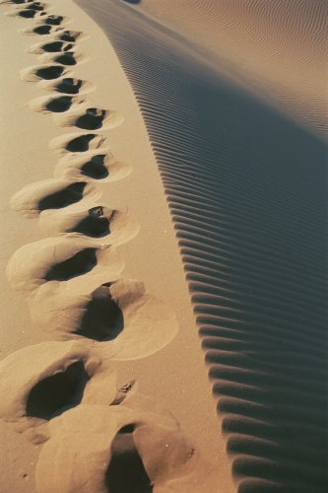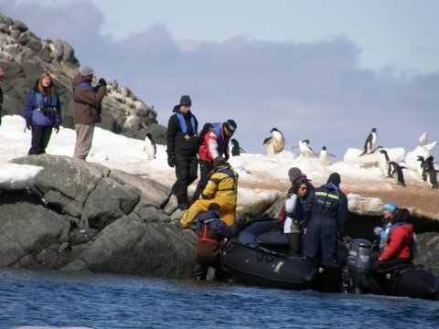

🛈 **Answer questions A – E or question F.**

**A**

**B**

**C**

**D**

**E**

**F**

**…how would you feel? Explain!**

**A few useful words:**

**cold, hot, seasick, tired, excited, adventurous, amazed…**

**…what would you smell? Explain!**

**A few useful words:**

**sweat, penguin-poo, camel –poo, salt, dead fish…**

**…what would you see? Explain!**

**A few useful words:**

**sand, a jeep, footsteps, snow, ice , boat, cameras...**

**… what could you touch? Explain!**

**A few useful words:**

**hot sand, cold snow, the ocean, sticky shirt, warm hat…**

**…what would you hear? Explain!**

**A few useful words:**

**a motorboat, a jeep, penguins, silence, waves, a bird…**

**Over to you!**

**Choose your own task, using the 2nd conditional form, to relate to these pictures.**

