2. The Travellers
Look at the pictures and answer the questions below.
- 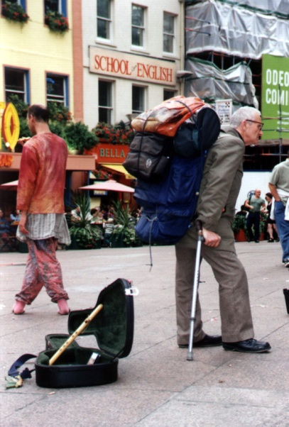 B) 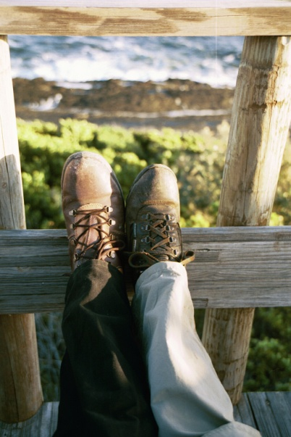

- Look at picture B.
Name two things that both legs have in common.
Name two things that are different
- Look at picture B.
Which leg belongs to a woman? Explain how you decided.
- Look at picture A.
Name one surprising things about the man in this picture? (hint – how old do you think the man is? What is in his hand?)
- Compare the shoes in both pictures. In what way are they different?
- What is the name of the "thinking skill" you used in this exercise?
- זכרתם? תרגמו את NAME כ "ציין"!

