2. The Travellers
Look at the pictures and answer the questions below.
- 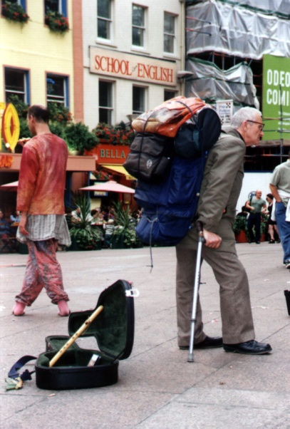 B) 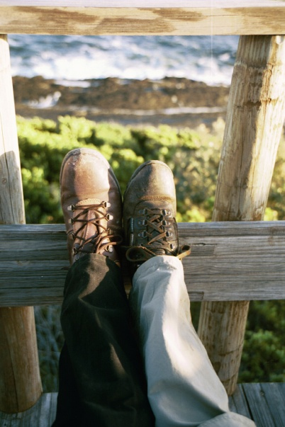

- Look at picture B. These legs do not belong to the same person.
Name two things that both legs have in common.
Name two things that are different
- One leg belongs to a woman. Can you infer which? Explain how you decided.
- Look at picture A. Name two surprising things about the man in this picture? (hint – how old do you think the man is? What is in his hand?)
- We can infer that the man in picture A has not rented a car. State one fact that supports your answer.
- Compare the shoes in both pictures. In what way are they different?
- We can infer that picture B was not taken in the city because _______________
- Where could you find such pictures?
- In a diary? b) In a travel magazine? c) In an encyclopedia?
- Which two "thinking skills" did you use in this exercise?

