Egghunt – Activities

List of words for the teacher.
(words with an asterisk denote words not on the official list).
Egg | buy | Take care! | hungry
Caveman* | Hunt * | Be careful! | long
Spear* | fall | That’s not fair! | angry
film | smile | How many | sad
food | watch |  | sure
another | break |  | true
 | see

- Lead-in activity, must be first  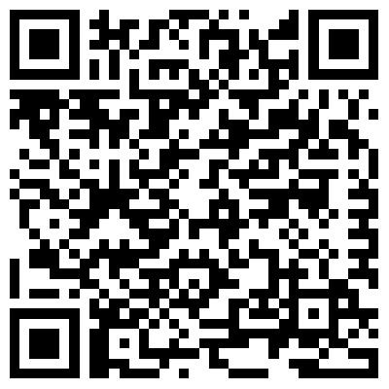 | - The film | - Film with embedded questions
- Sentence sorting game | - Flashcards | Hidden word search

