You can’t always believe what you see!
Read the following text and then answer the question below.
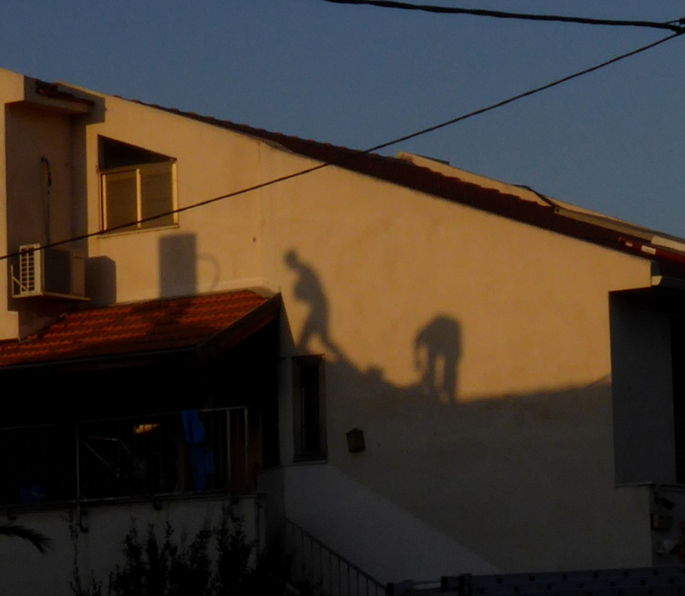
“The Ghost Workers” – Photo by Naomi Epstein

There is a saying: “Seeing is believing”. However, you shouldn’t believe everything you see. Look at this photograph, for example. Are the ghosts really walking on the wall? Of course not! These are shadows. There are many ways to trick the brain into believing things that aren’t true and even aren’t there. Magicians use such tricks all the time. We all should think logically before believing strange things that we see with our own eyes.
1. Copy a fact from the text that explains the title.

