Lesson Objectives
English objectives
- Students will be able to access information from a written text
- Students will be able to write a response to a reading.
Content Objectives
- Students will learn the value of give and take in life.

Lesson sequence:

- Show the students the video on this link:
https://www.youtube.com/watch?v=WFNXwor69-U
- Ask students to make the connection between the video and the title of the reading: Fun for Sick Kids
- Do the reading, using the comprehension questions.
- Show the students the video: (since the video has a lot of Hebrew, I would suggest lowering the sound so that the pupils can read the English subtitles).
https://www.youtube.com/watch?v=PqAkEmEIstI
- Students write a response to the reading. They can either apply for a job volunteering at the Jordan River Village or write about an idea they have about helping others and they would carry it out.

Fun for Sick Kids
Text from: Even More Unseens By Miriam Shtaierman – ECB Books
Presented here with permission from publishers

Paul Newman, the American film actor, is the head of a special group called "The Hole in the Wall Gang Camp *Association". The association is now planning to set up a holiday village in the Galilee for children and teenagers with serious *illnesses. A group made up of celebrities and business people in Israel have raised $3,000,000 to help build that village.

The special village is called the Jordan River Village and it will be built on 200 dunams opposite the Lavi Forest in the lower Galilee. In the village there will be a sports center and many enjoyable activities such as swimming, games, and horseback riding. The village is for Jewish, Muslim and Christian youngsters from Israel and from neighboring Arab Countries. The village will have 12 housing units for the children. They will spend a whole week there.

There are already five similar villages in the United States for youngsters with cancer or serious blood diseases. The idea is to help young people forget about their *suffering for a week. At this village, they will have some freedom and fun.
* association – איגוד
* illnesses – מחלות
* suffering – סבל 304
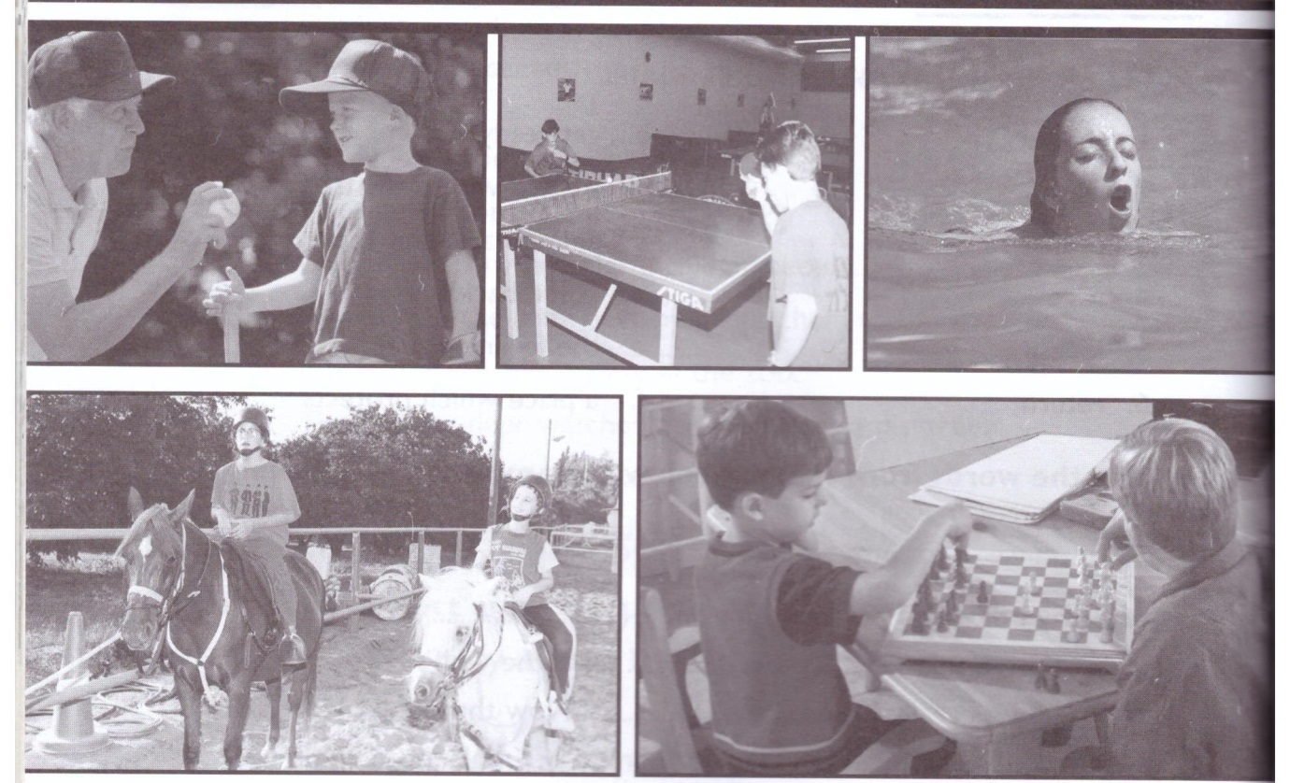

Fun for Sick Kids

Read the text and choose the correct answer
1. Paul Newman is:
a. a famous chef
b. an American singer
c. an American film actor
2. The holiday village will be set up in the:
a. Dead Sea
b. Galilee
c. Golan Heights
3. The special village is called:
a. The special river
b. The Galilee Village
c. The Jordan River
4. The holiday village is meant for:
a. Children with learning disabilities
b. Children and teenagers with serious illnesses
c. Healthy children
Answer True or False. Correct the false sentences.
1. In the village there will be sports centers and many boring activities such as tennis, games and horseback riding.
__________________________________________________________________
2. The village is for Jewish, Muslim and Christian youngsters.
__________________________________________________________________
3. The children and teenagers will spend two months in the holiday village.
___________________________________________________________________
4. There are eight similar villages in the United States.
___________________________________________________________________
5. At the village the kids will have freedom and fun.
___________________________________________________________________

