Uncovering Motives

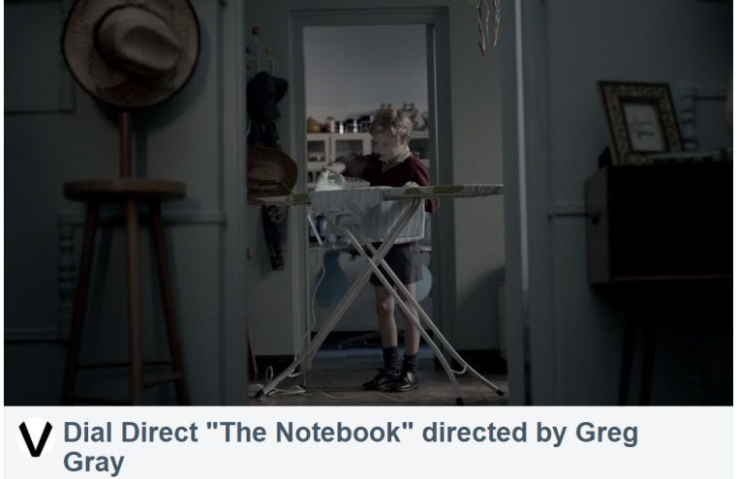

A. Watch the video, “The Notebook”. (2.15 min.)
https://vimeo.com/116523608

In the video, the boy Noah has a problem. Answer the questions on the next page about the video.

