The Present – Answer Sheet

People who send text messages on their cell phones often use abbreviations, such as “IDK” instead of “I don’t know”.

Part One:
Match the following abbreviations to their meanings
(Use the word bank below).
Add a translation into your language.

The Meaning | The Abbreviation | Translation
Mark My Words | MMW | הקשיבו לי היטב / זיכרו מה שאני אומר
In Case You Missed It | ICYMI | במקרה שפיספסת...
Thank You Very Much | TYVM | תודה רבה
Complete Waste of Time | CWOT | בזבוז זמן גמור
End of Discussion | EOD | סוף פסוק , אין על מה לדון
I don’t care | IDC | לא אכפת לי
Great | GR8 | נפלא, גדול
See you soon! | CUS | נתראה בקרוב!
Be right back | BRB | אחזור מייד / אשוב מייד
Laughing out loud | LOL | צוחק בקול רם
Oh my GOD | OMG | אלוהים אדירים
In my opinion | IMO | לפי דעתי

* In my opinion * Mark my words * Laughing out loud * See you soon * Great! * In case you missed it * Be right back! * Thank you very much! * Oh my GOD! * Complete waste of time! * End of discussion, * I don’t care

Part Two:
Watch the video “The Present”
Click on the blue box to go to the video:

Part Three:
Here are pictures from the video.
Write a suitable sentence for each picture using the options in the box below.
Important! Write complete sentences – don’t use abbreviations.

- 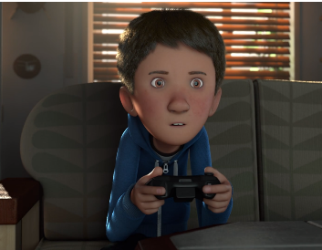
____ Mark my words, I am going to win! __________________

- 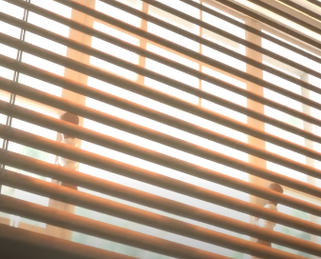
You can't sit in the dark. EOD!

- 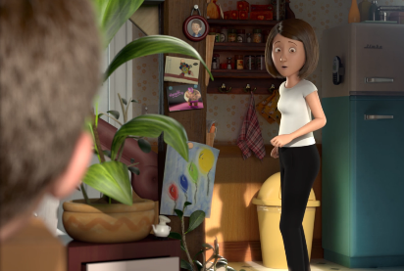
- __ For your information, that present is for you, sweetie.

- 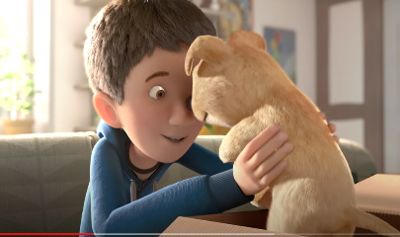
- ____________ Cool! This is great!
________________________________________
- ______ OMG! She's got to be kidding me!

__I don’t care__
- 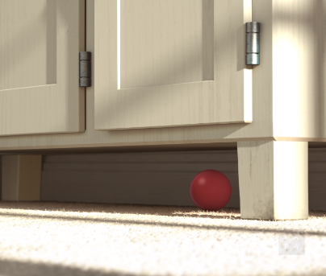
- __________________________ Oh look! A red ball! I will be right back.
_______________________
- 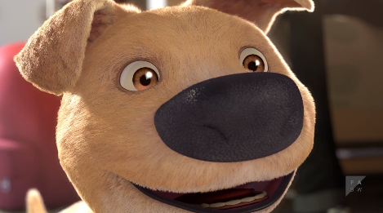
- _________ Thank you very much! Time to play!
___________________________________________
- 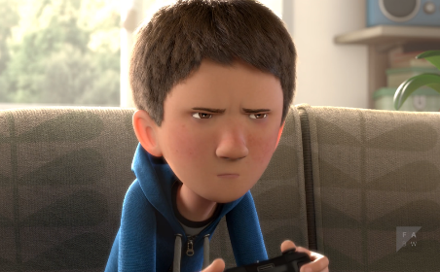
- In my opinion this dog is boring... Complete waste of time!
______________________________
____Laughing out loud__
- 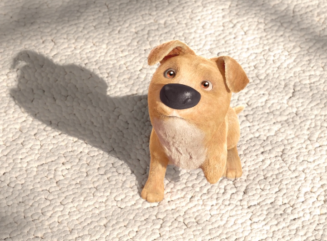
- In case you missed it, I brought you that ball. Don't you want to play with me?
___________________________________

- 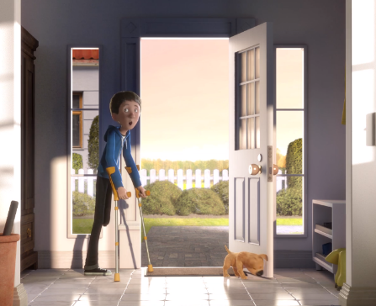
- _______________ Mom, we’re going outside. See you soon!
_____________________________________

- Cool! This is GR8!
- Mom, we’re going outside. CUS!
- Oh look! A red ball! I will BRB!
- MMW, I am going to win!
- ICYMI, I brought you that ball. Don't you want to play with me?
- LOL!
- FYI, that present is for you, sweetie.
- IMO this dog is boring... CWOT!
- TYVM! Time to play!
- IDC! Get Lost!
- OMG! She's got to be kidding me!
- You can't sit in the dark. EOD!

